ShopNest Power BI Capstone Report

Overview :-

This Power BI report is built using 9 datasets from the ShopNest retail business. It answers 8 key business questions related to sales, delivery performance, product ratings, payments, and regional trends.

Key Performance Indicators:

Here are the most relevant and impactful KPIs (Key Performance Indicators in your ShopNest Store Power BI Capstone project:

🔹 1. Total Revenue

Definition: Sum of all price and freight_value from order_items.

DAX Formula :

Total Revenue =SUM(order_items_dataset[price])+SUM(order_items_dataset[freight_value])

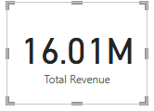

🔹 2. Total Orders

Definition: Count of unique order_id from the orders table.

DAX Formula : Total Orders = DISTINCTCOUNT('orders_dataset (1)'[order_id])

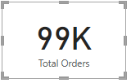

🔹 3. Total Customers

Definition: Number of unique customers.

DAX Formula : Total Customer = DISTINCTCOUNT(customers_dataset[customer_id])

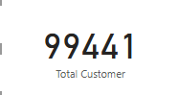

🔹 4. On-Time Delivery Rate

Definition: Percentage of orders delivered on or before the estimated date.

DAX Formula : On-Time Delivery Rate = DIVIDE(COUNTROWS(FILTER('orders_dataset (1)','orders_dataset (1)'[order_delivered_customer_date] <= 'orders_dataset (1)'[order_estimated_delivery_date])),COUNTROWS('orders_dataset (1)'))

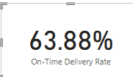

🔹 5. Total Delayed Orders

Definition: Number of orders where the delivery was late.

DAX Formula : Delayed Orders = COUNTROWS(FILTER('orders_dataset (1)','orders_dataset (1)'[order_delivered_customer_date] > 'orders_dataset (1)'[order_estimated_delivery_date]))

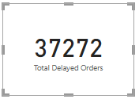

🔹6. Average Review Score

Definition: Average of all review scores.

DAX Formula : Avg Review Score = AVERAGE(order_reviews_dataset[review_score])

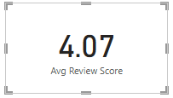

📌 Question:

1. Top Categories by Total Sales

> Identify which product categories generate the highest revenue. Represent the top 10 product categories by total sales using a suitable visual to highlight differences and trends

📊 Visual Description:

> Visual Type: Column Chart

X-axis: Product Category Name

Y-axis: Total Sales (in currency)

Filter: Top 10 product categories by total sales

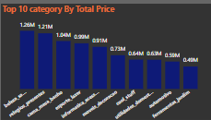

This visual presents a ranked Column chart showing the top 10 product categories in terms of total revenue. Each bar reflects the cumulative sales value for each product category.

---

💡 Key Insights:

beleza_saude is the top-performing category, generating total sales of ₹1,258,681.34, indicating high demand in the beauty and health segment.

relogios_presentes ranks second with ₹1,205,005.68, suggesting strong performance in gift and watch products, potentially due to seasonal sales or special occasions.

cama_mesa_banho is third with ₹1,036,988.68, highlighting steady demand in household essentials like bedding and bath products.

These three categories together contribute a significant share of the overall revenue, showing where the business earns most of its sales.

---

📈 Strategic Takeaways:

Marketing Focus: Invest more in advertising and bundling offers for top-performing categories, especially beleza_saude.

Stock Planning: Ensure optimal inventory for high-performing items to avoid stockouts.

Sales Trend Monitoring: Track trends in relogios_presentes to understand seasonal peaks (e.g., holidays or festivals).

Growth Opportunity: Analyze mid-performing categories to find potential for uplift through cross-selling or promotions.

📌 Question:

2. Delayed Order Analysis

> Determine the number of delayed orders in each product category. An order is considered delayed if the actual delivery date is later than the estimated delivery date.

---

📊 Visual Description:

> Visual Type: Column Chart

X-axis: Product Category Name

Y-axis: Number of Delayed Orders

Filter: Only orders where actual delivery date > estimated delivery date

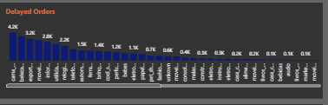

This bar chart visualizes the count of delayed orders per product category, helping identify which categories experience the most fulfillment delays.

---

📈 Key Insights:

cama_mesa_banho leads in delayed deliveries, indicating possible issues in bulk handling or packaging for home and bath items.

beleza_saude ranks second in delays, despite being the top category in total sales. This may impact customer satisfaction and suggests a need for faster restocking or more reliable shipping.

esporte_lazer is third in delays, possibly due to seasonal demand spikes or supplier bottlenecks.

These categories need special attention for improving delivery timelines, especially where customer expectations for fast shipping are high.

---

🧠 Strategic Recommendations:

Improve logistics efficiency and partner SLAs for high-delay categories.

Consider regional priority shipping options for top-selling but delayed products like beleza_saude.

Perform a root cause analysis on top delayed categories to identify whether issues stem from inventory, distance, or supplier delays.

📌 Question

3. Monthly Comparision Between Delayed And On Time Orders

1. Objective

To analyze and compare the number of delayed orders vs. on-time orders for each month, and provide a detailed drill-through report for in-depth delivery performance insights.

2. Approach

A stacked column chart was used to compare the monthly trend of delayed vs. on-time deliveries. A drill-through feature was implemented that allows users to right-click on a bar to explore details (order ID, customer_id, state, delivery status, Price,Total Sales).

This supports cross-report filtering using fields like:

- MonthName (from Date table)

- Orders (delivery status: Delayed / On Time)

3. Power BI Visuals Used

Stacked Column Chart:

- X-axis: Month Name

- Y-axis: Count of Orders

- Legend: Delivery Status (Orders)

KPI Cards:

- On-Time Rate (%): Approximately 60%

- Delayed Rate (%): Approximately 40%

Drill-through Table:

- Fields: Order ID, Customer ID, Month Name, Orders, Customer State, Review Score, Price, etc.

4. Drill-through Setup

Created a detail page: Detail Tab

Added the following to Drill-through filters:

- DateTable[MonthName]

- orders_dataset[Orders] (i.e., Delivery Status)

Relationship: orders_dataset[order_purchase_timestamp] → DateTable[Date] (Active)

5. Key Insights

- Approximately 60% of all orders are delivered on time, while 40% are delayed.

- Highest Delays were observed in categories like cama_mesa_banho, beleza_saude, esporte_lazer.

- On-time delivery rate improved during certain months like Jul 2017

- Delivery delays peaked in Feb indicating possible operational or seasonal impact.

- Drill-through helped identify which customers and products were involved in late deliveries.

6. Screenshots

Include the following images in your report:

1. Main Dashboard Visual (Monthly bar chart for delivery comparison)

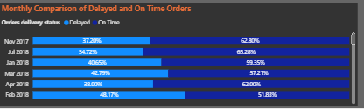

1. KPI Cards (showing 60% On-Time and 40% Delayed)



1. Drill-through Detail Page (Table view of selected month and delivery status)

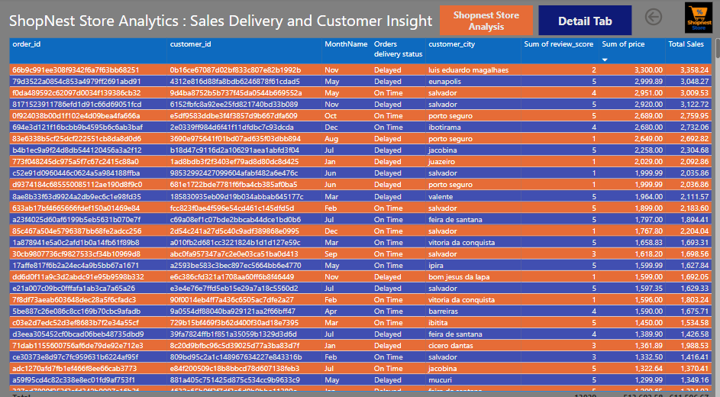

1. Model View showing relationship between orders_dataset and DateTable

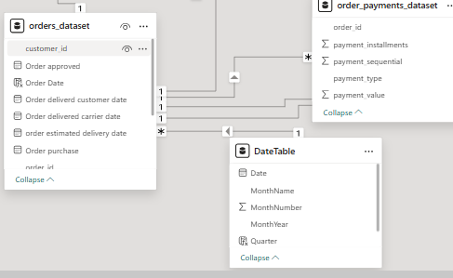

7. Conclusion

This report enables the business to:

- Monitor monthly delivery performance

- Identify high-delay periods and regions

- Take corrective actions (e.g., optimize logistics, manage vendor performance)

- Improve customer satisfaction and delivery reliability

The 60/40 split in delivery performance emphasizes the need for focused improvements in supply chain efficiency.

📌 Question:

4. Payment Method Analysis

1. Objective

To analyze the most frequently used payment method by customers and present the findings using a visually appealing chart such as a pie chart or bar chart.

2. Data Source

The analysis is based on the 'order_payments_dataset' table. Key columns used include:

- payment_type: the type of payment method used (e.g., credit_card, boleto, voucher)

- payment_value: Transaction Value

3. Visual Representation

A pie chart was used to represent the distribution of payment methods.

- Legend: payment_type

- Values: Count of payment_value

Pie Chart showing frequency of payment_type

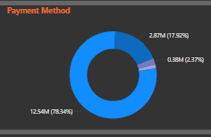

5. Key Insights

- The most frequently used payment method is credit_card.

- Other common methods include boleto and voucher.

- Pie chart reveals approximately:

• credit_card: 78%

• boleto: 17%

• Others (voucher, debit_card, etc.): 5%

- This insight helps in optimizing checkout options and promotions.

7. Conclusion

Understanding customer payment preferences enables businesses to streamline payment options, enhance user experience, and align promotions with popular methods. This analysis confirms that credit cards dominate transactions, but alternative methods like boleto also represent a significant share.

📌 Question:

5. Product Rating Analysis

Objective:

Determine the Top 10 highest-rated products and Bottom 10 lowest-rated products based on customer review scores. Present the results using bar/column charts for better clarity and comparison.

🗂️ Data Used

Order Reviews Table: Contains customer ratings (review_score) and product identifiers (order_id).

Order Items Table: Links each order to its products via order_id and product_id.

Products Table: Contains product names (product_id, product_category_name).

🧮 Step-by-Step Measures / DAX Calculations

1. Merge Data Tables in Power BI:

Join Order Reviews → Orders → Order Items → Products.

2. Create a Measure for Average Product Rating:

Average Rating = AVERAGE('Order Reviews'[review_score])

3. Create a Table Visual:

Include: product_id, product_category_name, and Average Rating.

4. Create Two Separate Bar/Column Charts:

Top 10 Highest-Rated Products:

Sort by Average Rating descending.

Use Top N filter: 10.

Bottom 10 Lowest-Rated Products:

Sort by Average Rating ascending.

Use Top N filter: 10

📷 Screenshot of Dashboard Visuals

Top 10 Highest-Rated Products

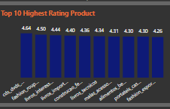

Bottom 10 Lowest-Rated Products

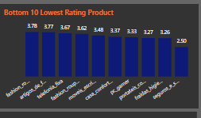

Make sure visuals include:

Clear X-axis labels (product names or IDs).

Y-axis as Average Rating.

Titles like “Top 10 Highest Rated Products” and “Bottom 10 Lowest Rated Products”.

📈 Visualization Explanation

Top 10 Highest Rated Products (rating 4–5).

Displays the products with the best customer satisfaction

Bottom 10 Lowest Rated Products (rating 1–2).

Highlights the products with the most dissatisfaction

These visuals help identify high-performing products and products that need quality improvement based on customer feedback.

💡 Insights and Recommendations

High-Rated Products can be featured in promotions or recommended more often.

Low-Rated Products may need to be reviewed for quality, description accuracy, or delivery issues

Question

6. State-wise Sales Analysis

Objective:

Identify and visually represent states with high and low sales to provide a clear understanding of regional sales performance. This helps in discovering potential growth regions or underperforming markets.

Visualize in Power BI:

📍 Map Visual

Use Filled Map or Shape Map.

Location: customer_state

Values: Total Sales

📷 Screenshot of Dashboard Visuals

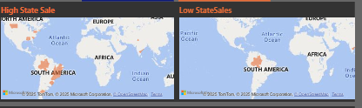

---

💡 Insights and Recommendations

States BA, SP, PI, MG (may show the highest sales → invest more in marketing and logistics.

States with low sales → investigate delivery delays, product availability, or customer reach.

📌 Question:

7. Seasonal Sales Pattern Analysis

🔍 Project Question: Seasonal Sales Pattern Analysis

Objective:

Investigate seasonal trends in sales by analyzing quarterly patterns over the course of a year. Identify whether certain quarters consistently show higher or lower sales, helping in demand planning, inventory management, and marketing strategy.-

🗂️ Data Used

Orders Table: Contains order_purchase_timestamp

Order Items Table: Contains Total revenue

Create a BarChart:

X-axis: Order Quarter

Y-axis: Total Revenue

📷 Screenshot of Dashboard Visual

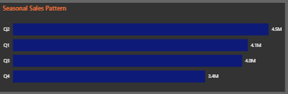

📈 Visualization Explanation

Visual Type Purpose

Bar Chart Helpful for comparing exact sales values between quarters.

🔍 Insights to Look For

Peaks in Q2 could indicate sales boost.

Lows in Q4 .

Use patterns for inventory stocking, discount scheduling, and marketing planning.

💡 Recommendations

Focus ads/promotions in high-performing quarters.

Investigate reasons behind low quarters—logistics, product availability, external factors.

Revenue Analysis Over Time

Question

8. Revenue Analysis Over Time

Objective:

Determine the total revenue generated by the store and analyze how revenue changes over time. Represent this data using appropriate visuals that clearly highlight trends, peaks, and fluctuations in revenue patterns.

🗂️ Data Used

Order Items Table: Contains price, freight_value, and order_id

Orders Table: Contains order_purchase_timestamp

---

Build a Line Chart or Area Chart

X-axis: Order Year-Month

Y-axis: Total Revenue

📷 Screenshot of Dashboard Visual

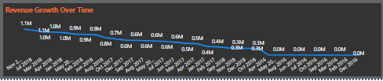

📈 Visualization Explanation

Chart Type Purpos

Line Chart Best for showing revenue trends month-over-month or quarter-over-quarter

🔍 Insights to Look For

Identify high revenue months/quarters

Detect seasonal dips or boosts

See if revenue is growing, declining, or flat over time

---

💡 Recommendations

Increase inventory or marketing in high-revenue months.

Investigate and fix issues during low-revenue periods (e.g., product availability, delivery issues).

Use insights to forecast future sales and set targets.